1. **Creating Line Transaction type**

**Navigation**

**Order Management Responsibility** > **Transaction Type** > **Define**

**Query the window with 10_StandardLine**

**Save after entering the details above**

**Order transaction Type**

Save details per screenshot below

**5. Main enter the following**

**-Default Order Line Type+10_StandardLine**

**6. Shipping Method**

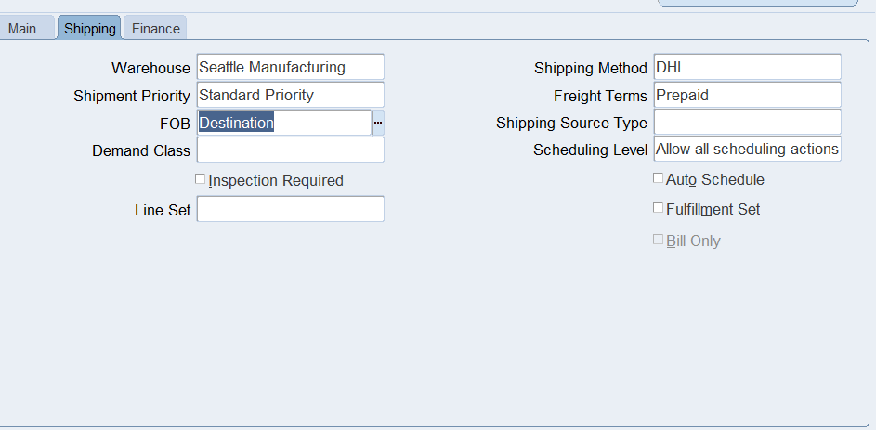

**7. Invoice Source**

**8). Save**

**9) Assign Line flows**

**Click Assign Line flows and enter the details below for Field and Value**

**Confirmation of 10_StandardLine**

**10. Creating documents sequence and assigning it to transaction type**

**11. Setup>Documents>Define**

**13. Save**

14.

**Create a sales order**

**Save and close window**

2. **Customer Management [Customer Creation]**

**Define and Maintain Customer Accounts and Contacts**

Create and maintain customer records, including their contacts.

**Steps:**

1. **Navigation Path:**

Go to **Order Management Responsibility** > **Customers** > **Standard**.

1) Order Management> Purchasing >Advance Pricing>Price List

Create Customer:

a) Click Create and enter:

▪ Customer Name:10_Customer

▪ Customer Type: Organization.

▪ Customer Number: Auto generated.

b) Add Contact Information:

In the Contacts tab, enter the contact’s name, email, and phone number.

Deliverables:

• Screenshot of the Customer Information screen.

• Screenshot of the Contacts Tab showing the entered contact details.

Define the customer's shipping and billing preferences.

1. In the Customer screen, navigate to the Addresses tab.

2. Create a new address:

-Enter Line 1, City, State, and Postal Code.

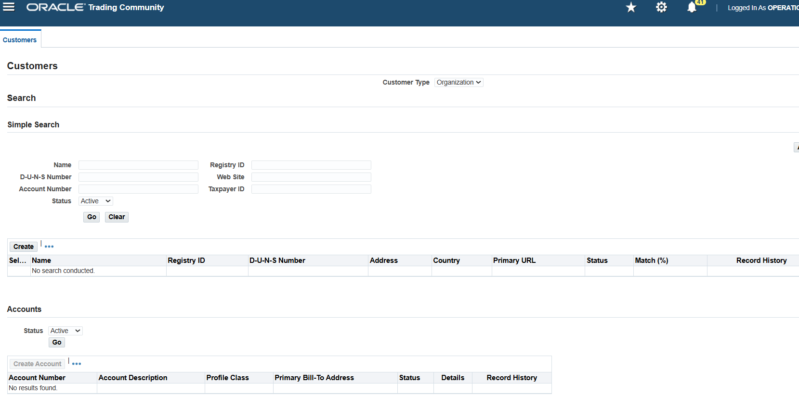

**Create customer as 10_Customer**

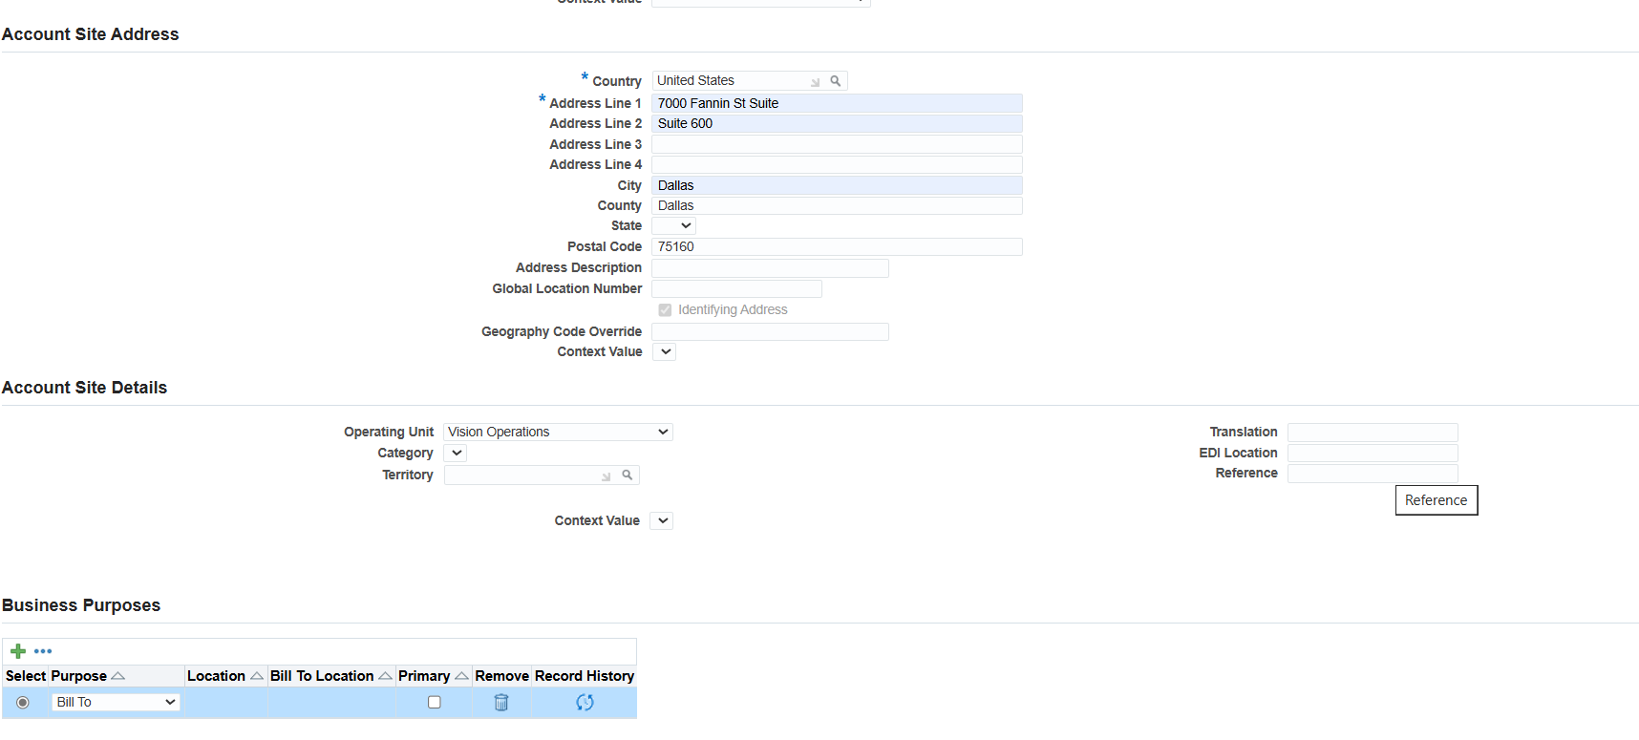

**Enter address details**

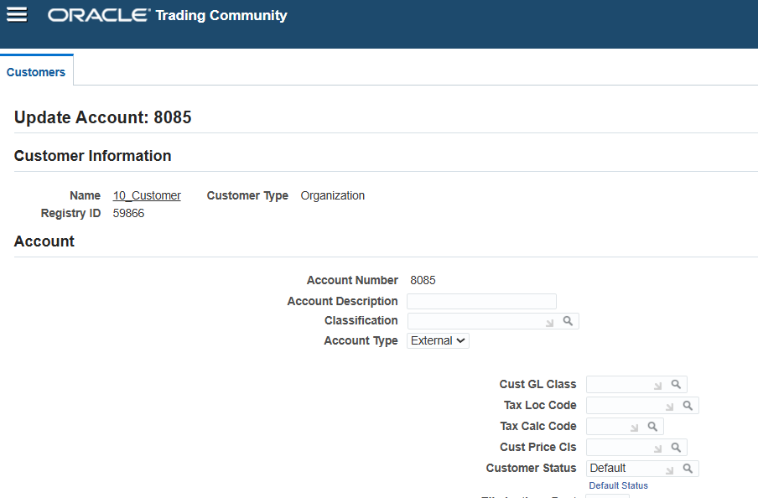

Confirmation page above

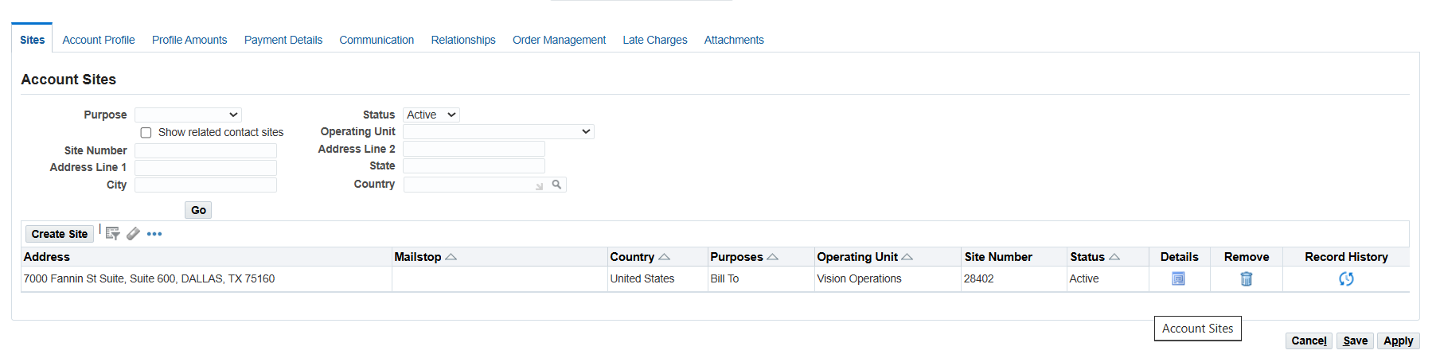





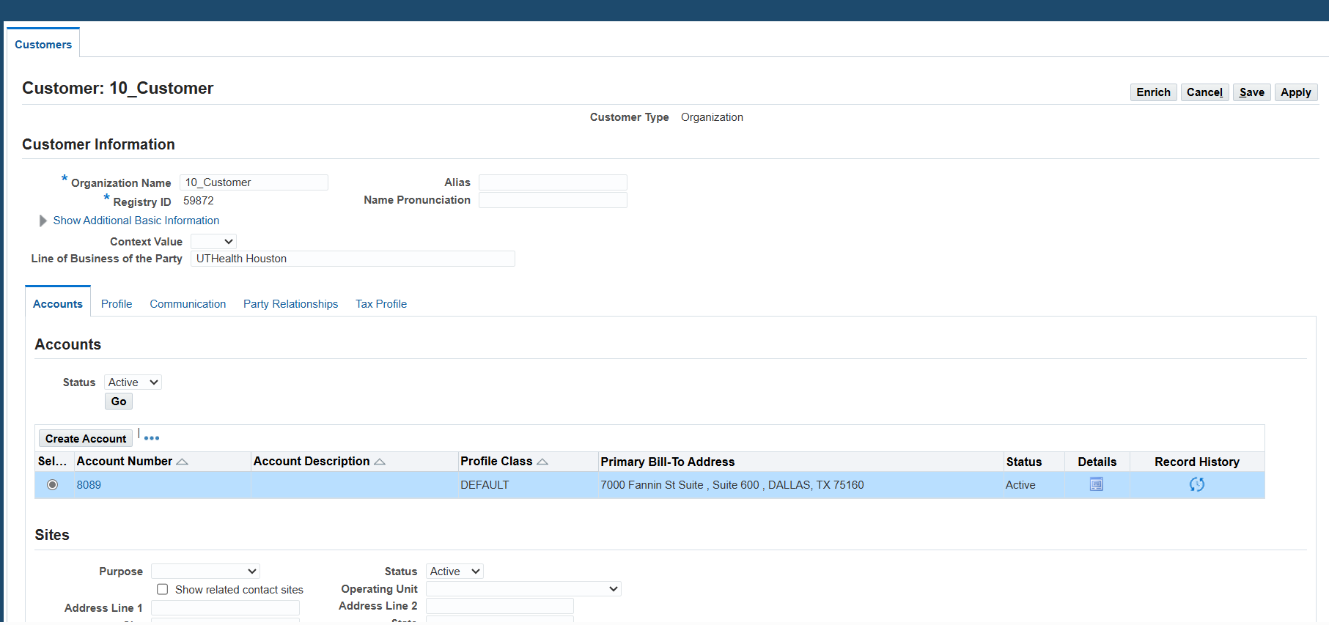

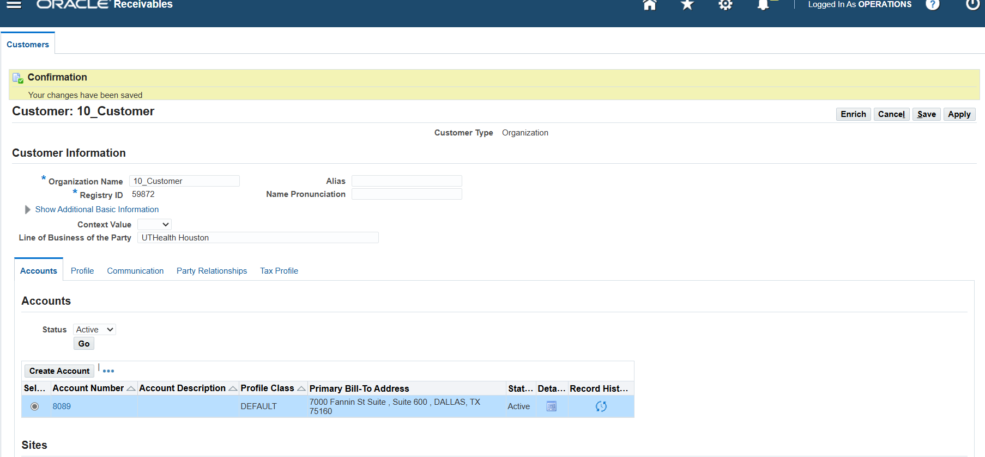

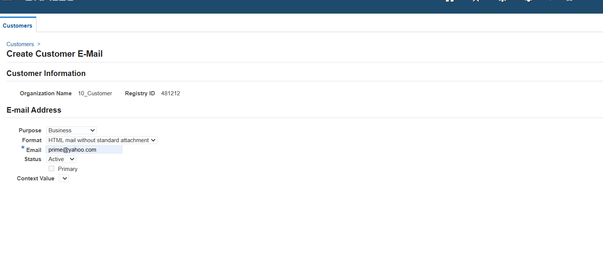

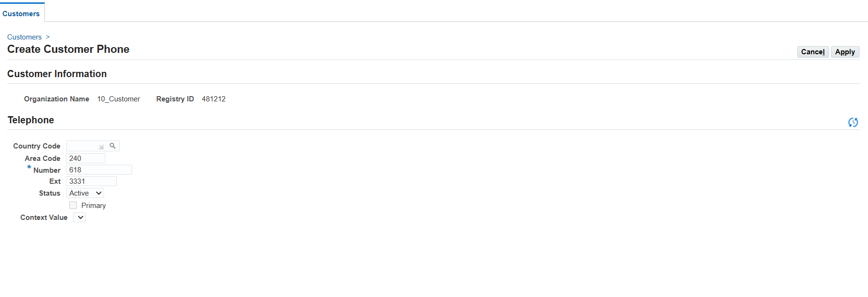

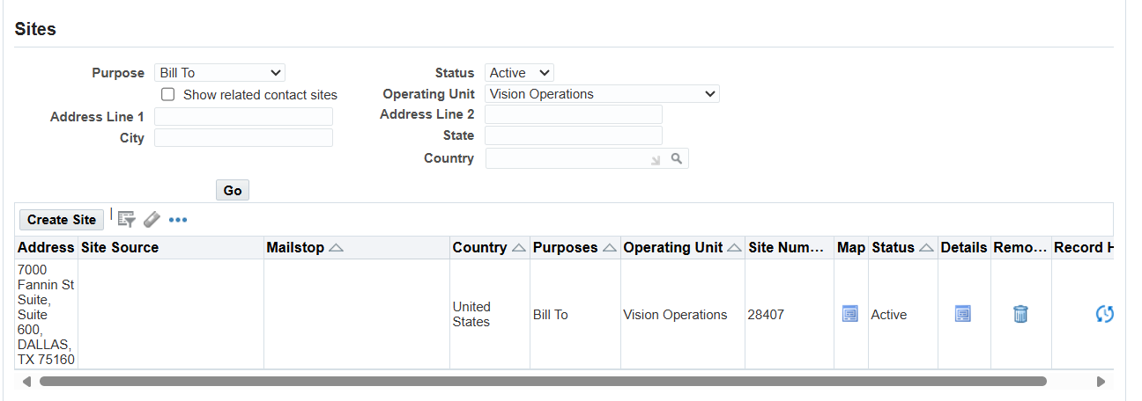

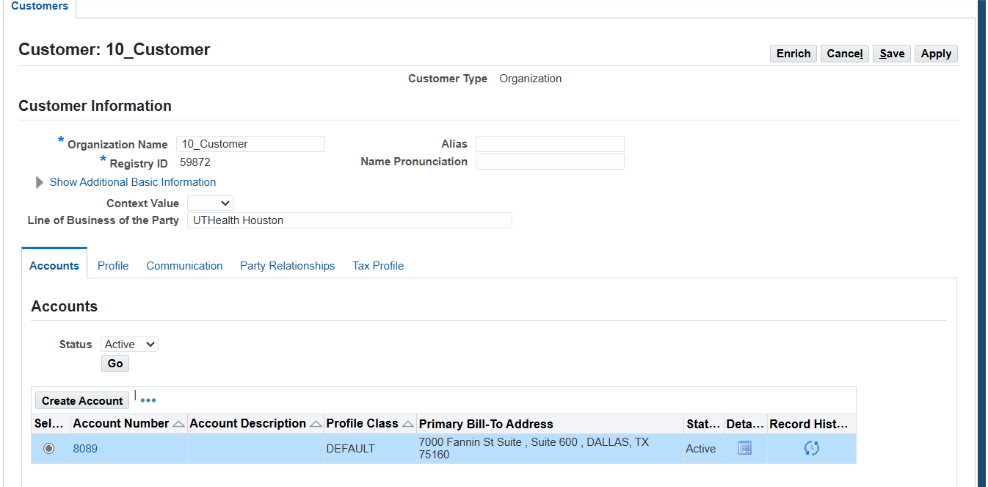

**2c). Manage Customer-Specific Pricing**

**Set up customer-specific pricing rules**.

1. **Navigation Path:**

**Order Management Responsibility** > **Purchasing** > **Price Lists Setup**.

**Save per screenshot below**

b) **Creating a Discount Modifier**

**Navigation**

**Purchasing > Advance Pricing > Modifiers > Modifier Setup**

**3)Order Management Responsibility > Orders, Returns > Sales Orders>.**

**Query the Window with customer already created 10_Customer**

**Order type search for 10_StandardOrder**

**Save the window**

